Day 3 Lab Programs

1. List processing and Sorting Algorithm

Code:
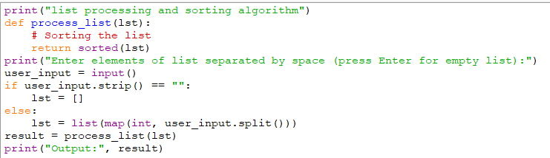

Output:
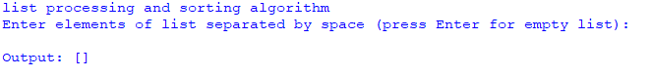

2. selection Sort

Code:
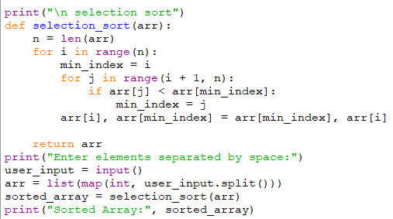

Output:
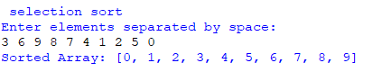

3. Bubble Sort

Code:
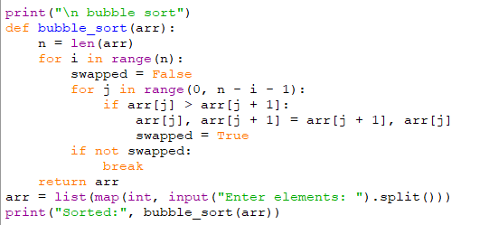

Output:
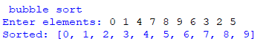

4. Insertion Sort

Code:
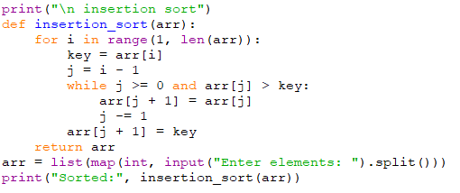
Output:
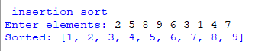

5. Kth Missing Element

Code:
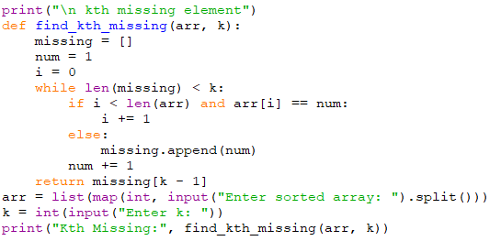

Output:
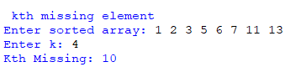

6. Peak Element

Code:
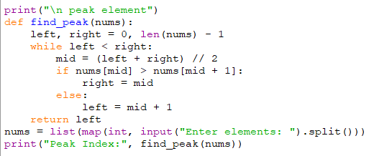

Output:
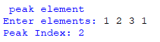

7. Occurrence of Substring

Code:
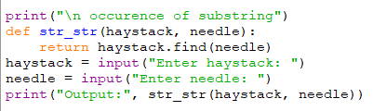

Output:
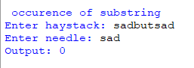

8. Substring of words from list

Code:
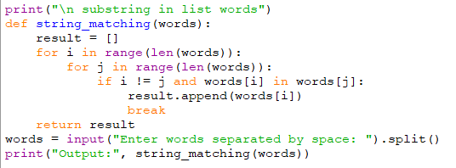

Output:
